Task: File System Commands

Objective
Perform basic file system commands on the target machine and get the flags.

Questions & Answers
# | Question | Answer
1 | What is the name of the file in the loot folder? | readme.txt
2 | What are the contents of readme.txt? | flag{you_know_cd_ls_cat_now}
3 | What are the contents of the hidden file in loot? | flag{you_found_the_hidden_file}

Commands Used
Command | Description
ls | List files in home directory — shows loot folder
cd loot | Navigate into the loot directory
ls -la | List all files including hidden ones in loot
cat readme.txt | Read readme.txt → flag{you_know_cd_ls_cat_now}
cat .hidden_file.txt | Read hidden file → flag{you_found_the_hidden_file}

Screenshot of Command Output
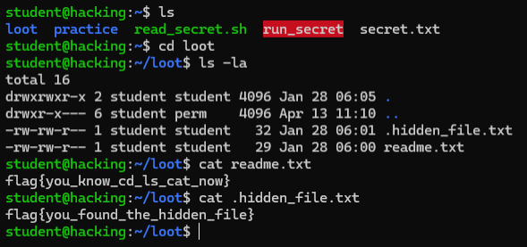
Figure 1: File system commands — both flags captured from loot folder

Environment Details
- Platform: TryHackMe (tutedude-cybersec room)
- OS: Ubuntu 24.04.4 LTS
- Target IP: 192.168.155.129
- Username: student
- Access Method: SSH via PowerShell

